**Basics**

The legislative CRM is built around three simple data constructs:  Constituents, Issues and Activities.

**Constituents**

Constituents are people (or institutions) and you can save basic information about them, like name, address, phone and email as well as additional personal data. The system is pre-loaded with all the registered voters in your district. Click the smiley icon to add constituents manually. Constituents will also be created when you record email messages that don’t match to existing constituents.

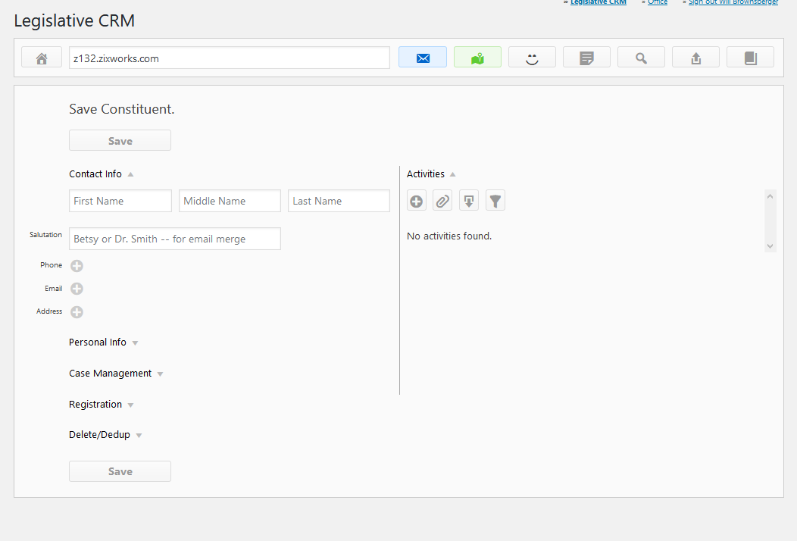

**Issues**

Issues are usually public policy issues. Each office defines its own issues. Typically, these are public policy issues that constituents are voicing opinions about.  An issue could also a grouping like “Town Meeting” or “Frequent Fliers” and you could identify constituents as members of it. You can group issues by category. Categories are created just by entering them on the issue form.

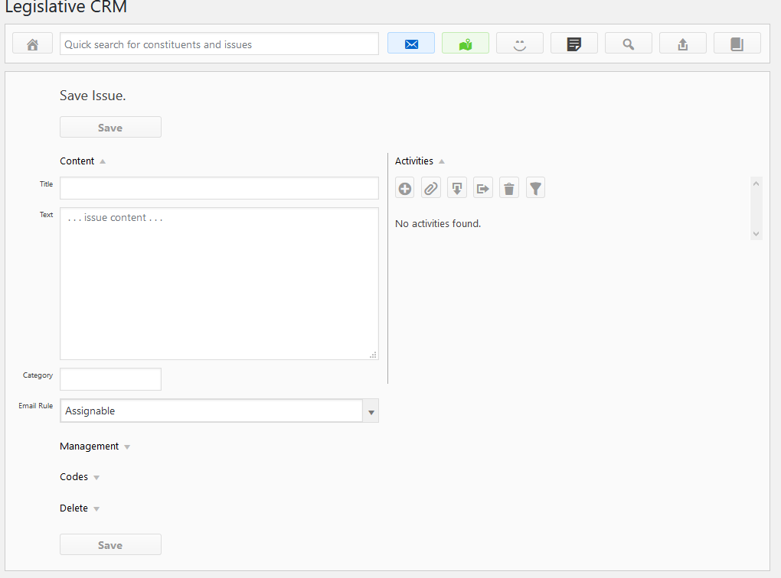

New issues can also be created when answering emails – just click the plus to create an issue with the same title as the subject line of the email. In the example below, clicking the plus sign would create an issue with the title “This is just a test message.”

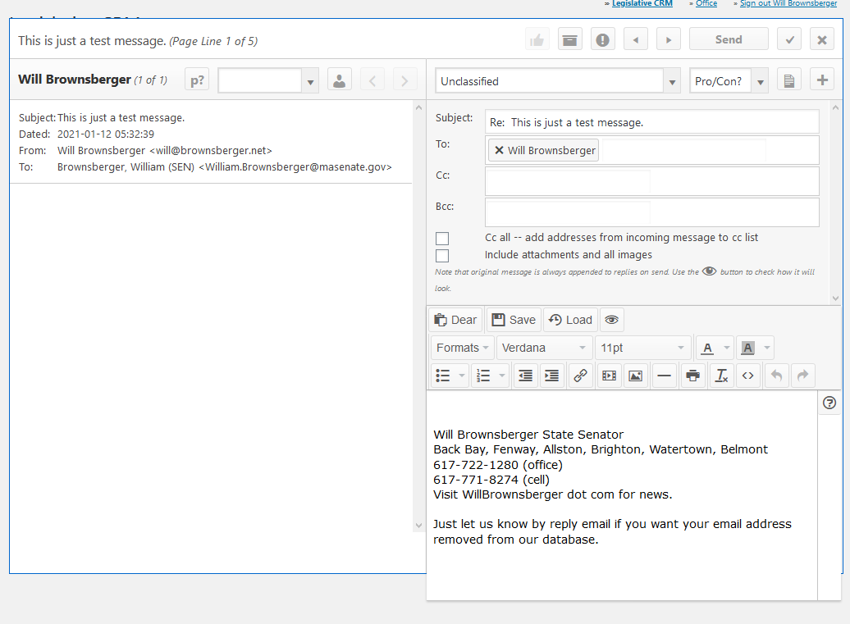

**Activities**

Activities represent things that a constituent might do or be with respect to an issue.  Activities are created automatically when email messages are recorded. Activities can also be added manually using the activity form that is available by clicking the plus sign within the issue and constituent forms. Previously added activities can be viewed or edited using the pencil icon.

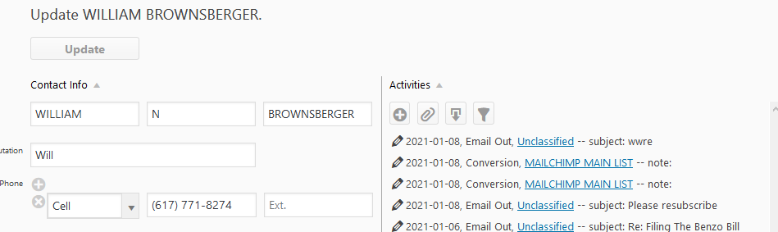

The following is a list of the valid activity types:

* eMail
* Call
* Petition
* Meeting
* Letter In
* Letter Out
* Social Media Contact
* Conversion
* Case Closure
* Member Of
* Document -- generated when a document is uploaded.
* Email In and Email Out -- generated automatically as emails are handled.